Allah’s
Name To Begin The Most Beneficent The Most Merciful .

Project Report

Assembly of Rack and Pinion
(Orange’s Juice Machine)

Mechanical Technology
Govt. College of Technology , Multan .
Roll Numbers | Name of Students
2K10-306 | Muhammad Kashif
2K10-309 | Naveed Ahmed
2K10-310 | Waqas Ahmed
2K10-338 | Abdul Rehman Aslam
2K10-345 | Muhammad Ali Shan

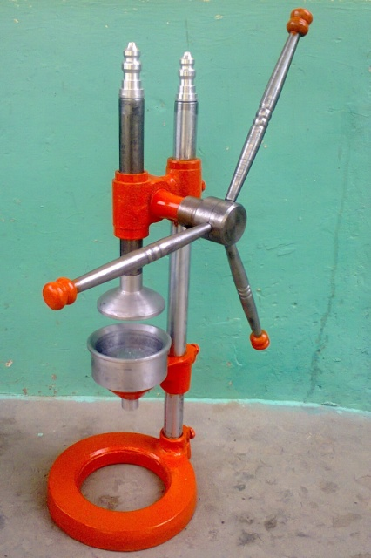
Our Guides

Mr. Tanveer Ahmed Chaudhary
(Instructor)

Mr. Khalid Jameel
(Assistant)

Mr. Muhammad Shokat
(Assistant)

Mr. Muhammad Majid
(Lab Attendant)

Preface :
Technical education plays a very important role in our life and in the development of a country without this any industry or country cannot develop.
In technical education we are part of Mechanical Technology which means shows that we make machines to make a work easiest short. By machines we can work without hard effort , for a best work we just need to concentrate on our work and we would be able to achieve our goals .

Information about project :
Our project known as assembly of rack and pinion in which we have to show working condition of rack and pinion that how rack and pinion works and what are the calculations of cutting rack and pinion .
We decided to show assembly of rack and pinion in an Orange’s Juice Machine because in this machine by the working of rack and pinion we can get juice of orange by applying a light effort , in short time and easily . So we can say that assembly of rack and pinion could be shows in this machine .

Processes:
To make this project we have to do some processes or we can say on working some processes we can complete our project.
There are some following processes to do :
- Casting (Foundry Shop)
  - Pattern Making
  - Molding
  - Casting
- Machining (Machine Shop)
  - CNC operations
  - Turning
  - Facing
  - Drilling
  - Boring
  - Threading
  - Tapping
- Welding (Welding Shop)
  - Arc Welding
  - Gas Welding
- Rack and pinion cutting (Machine Shop)
  - Indexing

- Casting:
In casting’s process we have to do following steps.
  - Pattern Making
To cast a part in foundry shop we need a pattern which is made of wood or any material that is use to make cavity in mold so we made patterns for our casting .
  - Molding
After making pattern we have to make mold in molding box with sand . By keeping the pattern in mold we can get cavity to pour molten matel .
  - Casting
After molding we boil cast iron to pour in the mold ant after the melting of cast iron we poured it into the mold cavity and as a result we have our needing parts .

- Machining:
When we have casted parts then we can see that they parts are need to finish . For finishing we use lathe machine or grinder so that they parts can be finished and used in our desirable place . On this step we have completed our casting’s parts and now they are ready to use . In this step we have to do following operations .

- Turning
In this operation we turned our jobs and decrease their diameters and we got our required jobs .

- Facing
By facing we decreased the length of the pieces or end of the jobs are finished by facing .

- Drilling
By drilling we got holes for threading which we used to fit a bolt or insert a rod .

- Boring
After drilling if we had not gotten our required hole then we take help of boring because drilling is standard holes and boring as we required .

- Threading
In this process we made calculated threads on our jobs so that we can assemble our work pieces and make a project.

- Tapping
In small pieces or solid pieces on which we could not make threads on those we performed tapping and as a result we got internal threads .

- CNC Machine :
On CNC we made show pieces for juice machine by input drawing method . We just draw a drawing and the process our billet and as a result we got our required show pieces .

- Welding:
After the process of machining some parts are needed to weld for reliable consolidation or permanent joints so that the joints have long life and no any accident will occur .During welding process we have to follow safety rules for welding so that we can complete process safely.

- Rack and Pinion cutting:
For cutting of rack and pinion we have to work on milling machine. On milling machine by the calculation we can cut rack and pinion. Calculation is necessary so that rack and pinion work properly. Otherwise without calculation rack and pinion after assembly cannot work properly.

Pictures
Base of Juice Machine
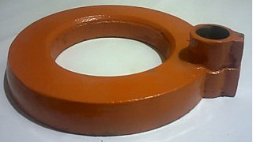
A part which supports rack and pinion .
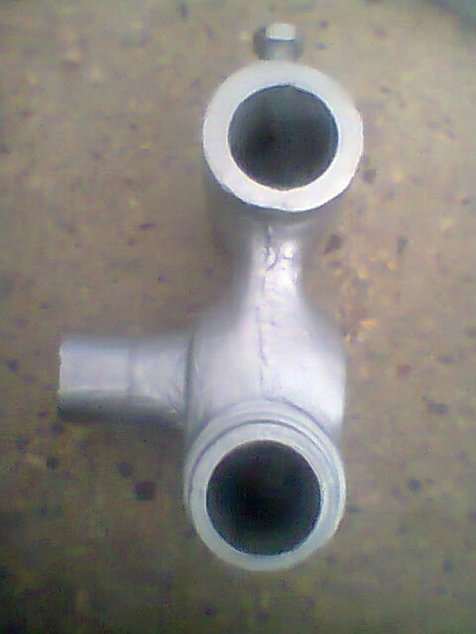
Funnel’ Support .
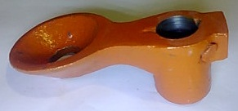

Parts of handle of Juice Machine .
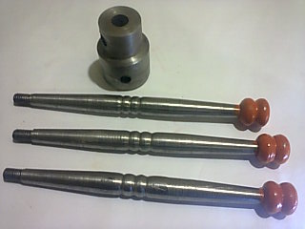
Assembled Handle .

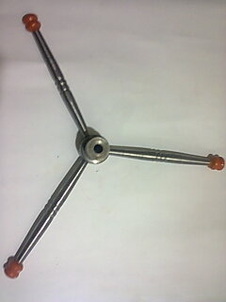
Rack for Juice Machine .
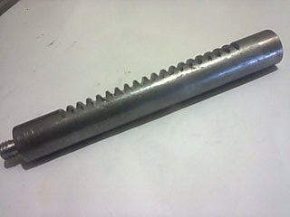
Pinion for Juice Machine .
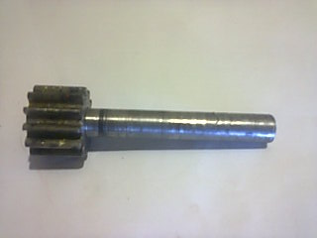

Show pieces made on CNC Machine .
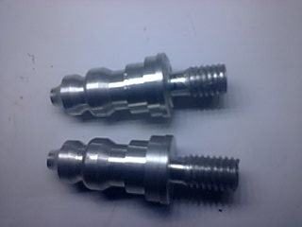

Pressing part in funnel .
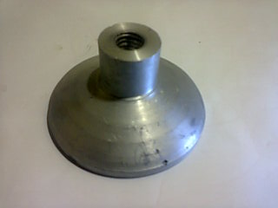
Grate for Juice in Funnel
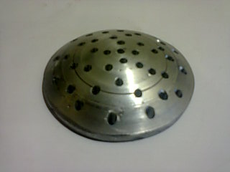

Funnel of Juice Machine .
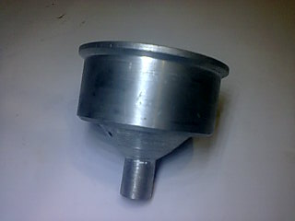

Assembled Juicer Machine
